Tab 3
ITA0601
MACHINE LEARNING
EXP 13
Implement the Car Price Prediction Model using Python

Procedure
1. Import the Linear Regression model from the relevant Python library.
2. Construct the dataset with feature values and target labels.
3. Train the Linear Regression model using the training data.
4. Predict the car price for a new sample input.
5. Output and display the prediction results.

Dataset 1: Basic Car Price Prediction
Car Age (Years) | Mileage (km) | Engine Size (cc) | Target Variable: Price (₹ Lakhs)
1 | 12000 | 1200 | 8.5
2 | 18000 | 1200 | 8.0
3 | 25000 | 1300 | 7.4
4 | 35000 | 1400 | 6.8
5 | 45000 | 1500 | 6.1
6 | 55000 | 1500 | 5.5
7 | 65000 | 1600 | 5.0
8 | 75000 | 1600 | 4.5
9 | 85000 | 1800 | 4.0
10 | 95000 | 1800 | 3.5

New Sample for Prediction
Car Age (Years) | Mileage (km) | Engine Size (cc)
4 | 38000 | 1400

Program
import numpy as np

X = np.array([
[1, 12000, 1200],
[2, 18000, 1200],
[3, 25000, 1300],
[4, 35000, 1400],
[5, 45000, 1500],
[6, 55000, 1500],
[7, 65000, 1600],
[8, 75000, 1600],
[9, 85000, 1800],
[10, 95000, 1800]
])

y = np.array([8.5, 8.0, 7.4, 6.8, 6.1, 5.5, 5.0, 4.5, 4.0, 3.5])

X = np.column_stack((np.ones(len(X)), X))

coefficients = np.linalg.inv(X.T @ X) @ X.T @ y

new_sample = np.array([1, 4, 38000, 1400])

prediction = new_sample @ coefficients

print("Predicted Car Price:", prediction, "Lakhs")

OUTPUT
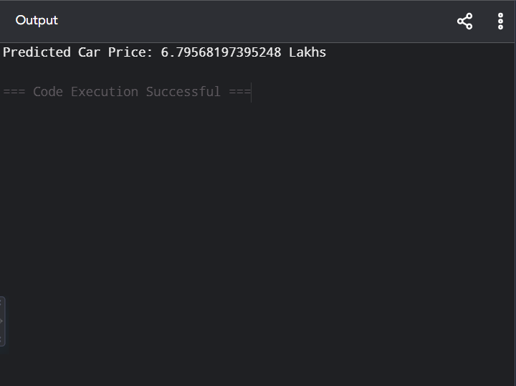

Dataset 2: Advanced Car Price Prediction
Manufacturing Year | Mileage (km) | Fuel Efficiency (km/L) | Target Variable: Price (₹ Lakhs)
2024 | 10000 | 22 | 10.5
2023 | 18000 | 21 | 9.8
2022 | 25000 | 20 | 9.0
2021 | 35000 | 19 | 8.2
2020 | 45000 | 18 | 7.5
2019 | 55000 | 17 | 6.8
2018 | 65000 | 16 | 6.0
2017 | 75000 | 15 | 5.4
2016 | 85000 | 14 | 4.8
2015 | 95000 | 13 | 4.2

New Sample for Prediction
Manufacturing Year | Mileage (km) | Fuel Efficiency (km/L)
2021 | 32000 | 19

PROGRAM

# Linear Regression - Used Car Price Prediction

X = [
[2024, 10000, 22],
[2023, 18000, 21],
[2022, 25000, 20],
[2021, 35000, 19],
[2020, 45000, 18],
[2019, 55000, 17],
[2018, 65000, 16],
[2017, 75000, 15],
[2016, 85000, 14],
[2015, 95000, 13]
]

y = [10.5, 9.8, 9.0, 8.2, 7.5, 6.8, 6.0, 5.4, 4.8, 4.2]

# Normalize data
Xn = []
for row in X:
Xn.append([(row[0]-2015)/10, row[1]/100000, row[2]/25])

w = [0, 0, 0]
b = 0
lr = 0.01

# Training
for epoch in range(10000):
for i in range(len(Xn)):
pred = b + w[0]*Xn[i][0] + w[1]*Xn[i][1] + w[2]*Xn[i][2]
error = pred - y[i]

w[0] -= lr * error * Xn[i][0]
w[1] -= lr * error * Xn[i][1]
w[2] -= lr * error * Xn[i][2]
b -= lr * error

# New input
new = [(2021-2015)/10, 32000/100000, 19/25]

prediction = b + w[0]*new[0] + w[1]*new[1] + w[2]*new[2]

print("Predicted Car Price:", round(prediction, 2), "Lakhs")

OUTPUT

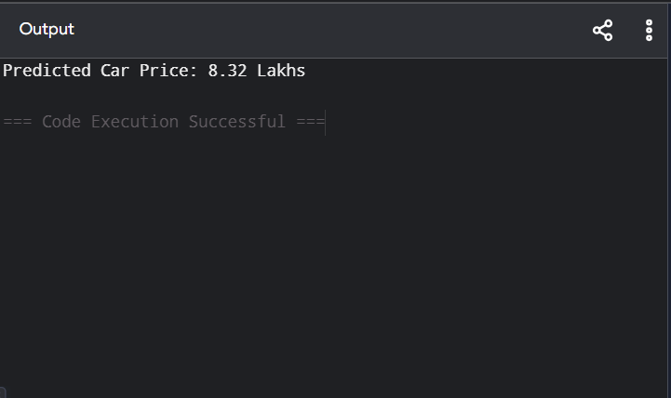

Dataset 3: Sedan Car Price Prediction
Engine Capacity (cc) | Horsepower | Mileage (km) | Target Variable: Price (₹ Lakhs)
1000 | 70 | 10000 | 6.5
1200 | 82 | 15000 | 7.4
1400 | 95 | 22000 | 8.8
1500 | 105 | 30000 | 9.8
1600 | 115 | 38000 | 10.5
1800 | 130 | 45000 | 11.8
2000 | 145 | 52000 | 13.2
2200 | 160 | 60000 | 14.5
2400 | 175 | 68000 | 15.8
2600 | 190 | 76000 | 17.2

New Sample for Prediction
Engine Capacity | Horsepower | Mileage
1700 | 120 | 42000

PROGRAM

# Linear Regression - Sedan Car Price Prediction

X = [
[1000, 70, 10000],
[1200, 82, 15000],
[1400, 95, 22000],
[1500, 105, 30000],
[1600, 115, 38000],
[1800, 130, 45000],
[2000, 145, 52000],
[2200, 160, 60000],
[2400, 175, 68000],
[2600, 190, 76000]
]

y = [6.5, 7.4, 8.8, 9.8, 10.5, 11.8, 13.2, 14.5, 15.8, 17.2]

Xn = []
for row in X:
Xn.append([row[0]/3000, row[1]/200, row[2]/80000])

w = [0, 0, 0]
b = 0
lr = 0.01

for epoch in range(10000):
for i in range(len(Xn)):
pred = b + w[0]*Xn[i][0] + w[1]*Xn[i][1] + w[2]*Xn[i][2]
error = pred - y[i]

w[0] -= lr * error * Xn[i][0]
w[1] -= lr * error * Xn[i][1]
w[2] -= lr * error * Xn[i][2]
b -= lr * error

new = [1700/3000, 120/200, 42000/80000]

prediction = b + w[0]*new[0] + w[1]*new[1] + w[2]*new[2]

print("Predicted Car Price:", round(prediction, 2), "Lakhs")

OUTPUT

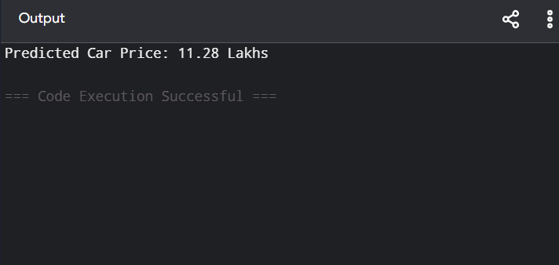

Dataset 4: SUV Price Prediction
Engine Capacity (cc) | Vehicle Age (Years) | Distance Travelled (km) | Target Variable: Price (₹ Lakhs)
1500 | 1 | 12000 | 15.5
1800 | 2 | 20000 | 14.8
2000 | 3 | 28000 | 13.9
2200 | 4 | 36000 | 13.0
2400 | 5 | 44000 | 12.0
2600 | 6 | 52000 | 11.0
2800 | 7 | 60000 | 10.2
3000 | 8 | 68000 | 9.4
3200 | 9 | 76000 | 8.7
3400 | 10 | 84000 | 8.0

New Sample for Prediction
Engine Capacity | Vehicle Age | Distance Travelled
2100 | 4 | 34000

PROGRAM

# Linear Regression - SUV Price Prediction

X = [
[1500, 1, 12000],
[1800, 2, 20000],
[2000, 3, 28000],
[2200, 4, 36000],
[2400, 5, 44000],
[2600, 6, 52000],
[2800, 7, 60000],
[3000, 8, 68000],
[3200, 9, 76000],
[3400, 10, 84000]
]

y = [15.5, 14.8, 13.9, 13.0, 12.0, 11.0, 10.2, 9.4, 8.7, 8.0]

Xn = []
for row in X:
Xn.append([row[0]/3500, row[1]/10, row[2]/90000])

w = [0, 0, 0]
b = 0
lr = 0.01

for epoch in range(10000):
for i in range(len(Xn)):
pred = b + w[0]*Xn[i][0] + w[1]*Xn[i][1] + w[2]*Xn[i][2]
error = pred - y[i]

w[0] -= lr * error * Xn[i][0]
w[1] -= lr * error * Xn[i][1]
w[2] -= lr * error * Xn[i][2]
b -= lr * error

new = [2100/3500, 4/10, 34000/90000]

prediction = b + w[0]*new[0] + w[1]*new[1] + w[2]*new[2]

print("Predicted Car Price:", round(prediction, 2), "Lakhs")

OUTPUT

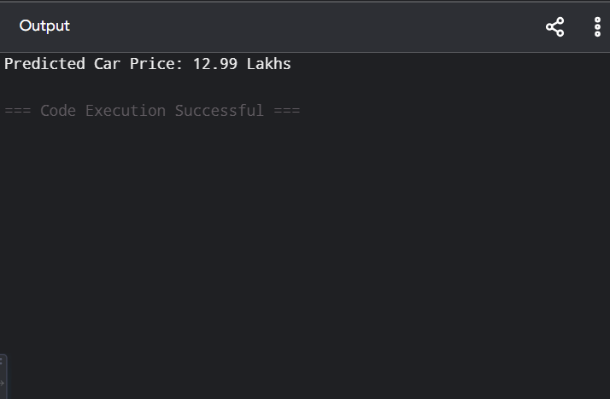

Dataset 5: Electric Car Price Prediction
Battery Capacity (kWh) | Range (km) | Charging Time (Hours) | Target Variable: Price (₹ Lakhs)
30 | 250 | 8 | 10.5
35 | 300 | 8 | 12.0
40 | 350 | 7 | 14.0
45 | 400 | 7 | 15.8
50 | 450 | 6 | 17.5
55 | 500 | 6 | 19.2
60 | 550 | 5 | 21.0
65 | 600 | 5 | 22.8
70 | 650 | 4 | 24.5
75 | 700 | 4 | 26.2

New Sample for Prediction
Battery Capacity | Range | Charging Time
52 | 470 | 6

PROGRAM

# Linear Regression - Electric Car Price Prediction

X = [
[30, 250, 8],
[35, 300, 8],
[40, 350, 7],
[45, 400, 7],
[50, 450, 6],
[55, 500, 6],
[60, 550, 5],
[65, 600, 5],
[70, 650, 4],
[75, 700, 4]
]

y = [10.5, 12.0, 14.0, 16.5, 18.5, 21.0, 24.0, 27.5, 31.0, 35.0]

Xn = []
for row in X:
Xn.append([row[0]/80, row[1]/750, row[2]/10])

w = [0, 0, 0]
b = 0
lr = 0.01

for epoch in range(10000):
for i in range(len(Xn)):
pred = b + w[0]*Xn[i][0] + w[1]*Xn[i][1] + w[2]*Xn[i][2]
error = pred - y[i]

w[0] -= lr * error * Xn[i][0]
w[1] -= lr * error * Xn[i][1]
w[2] -= lr * error * Xn[i][2]
b -= lr * error

new = [52/80, 470/750, 6/10]

prediction = b + w[0]*new[0] + w[1]*new[1] + w[2]*new[2]

print("Predicted Car Price:", round(prediction, 2), "Lakhs")

OUTPUT

